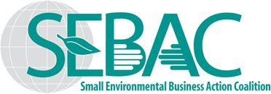
The Acquisition Strategy Committee (ASC) is pleased to send you the “The Acquisition Strategy Update,” a monthly recap of what’s going on at the agencies and small business programs we track. If you have any information you would like to share with our members regarding your client agencies or small business programs, please get in touch with John Dwyer, SEBAC President or Doug DeFazio, Acquisition Strategy Committee Chairman.
ACQUISITION STRATEGY UPDATE FOR MAY 2021
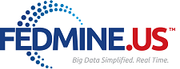 NAICS CODES REPORT
Procurement information for NAICS codes provided by Associate Member, FEDMINE.US.
For more information regarding these reports, contact Archisha Mehan at archisha@fedmine.us
NAICS CODES 562910
- Contracts
- RFPs
NAICS CODES 541620
- Contracts
- RFPs
UPCOMING TELECONFERENCES
Friday, June 25, 2021, Noon EDT
Friday, July 23, 2021, Noon EDT
REMINDER
The Board of Directors Election will be held in early August. To be eligible to participate, membership dues must be current.
SAVE THE DATE
SAME SBC - November 15 - 19, 2021 in Atlanta, GA

